ASK ANYTHING

Rebuilding the
Diabetic Nerve
Neurovascular repair and selective sodium-channel inhibition
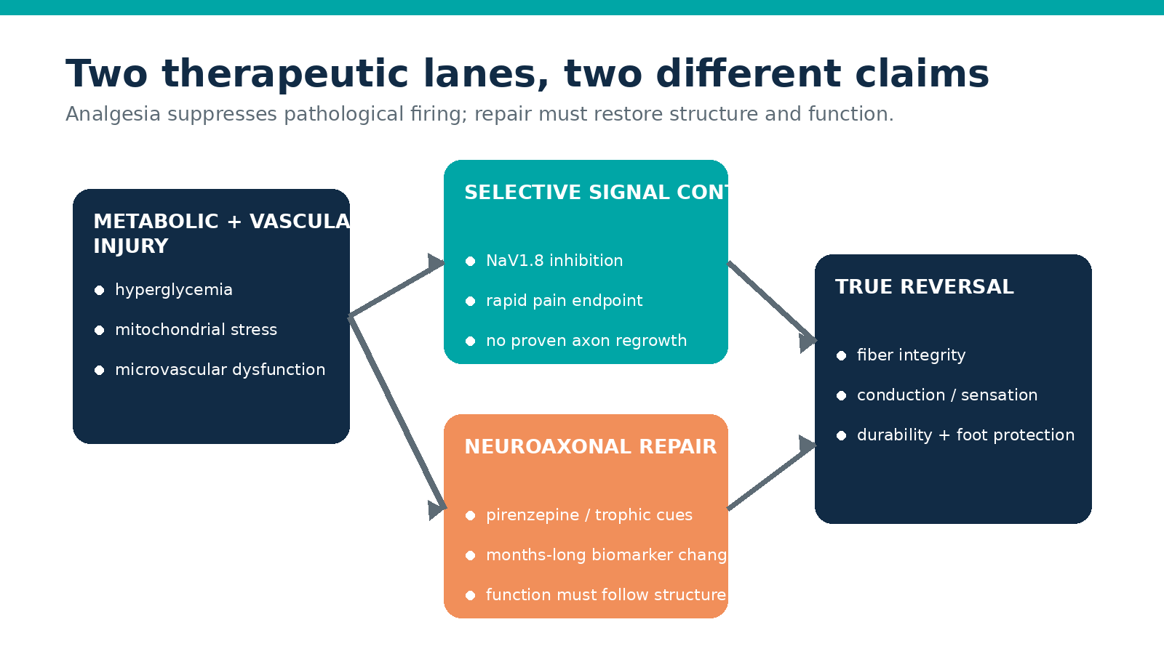
Advanced evidence review • Current to 26 July 2026

Contents
- Executive summary
- Key findings
- 1. What would “reverse nerve signal loss” actually mean?
- 2. Selective sodium-channel inhibition
- 3. Neurovascular and axonal repair
- 4. A rational next-generation trial architecture
- 5. Documented development examples
- Practical synthesis
- Evidence and caveats
- Sources

An advanced translational and clinical evidence review for neurologists, diabetologists, pain specialists, and trialists — evidence current to 26 July 2026
Clinical boundary. No therapy is presently proven to restore lost nerve signaling in established diabetic peripheral neuropathy (DPN). The candidates discussed below are investigational for DPN unless stated otherwise. This report distinguishes pain relief from axonal repair and is not patient-specific treatment advice.

Executive summary
The most credible near-term breakthrough is selective inhibition of NaV1.8 with suzetrigine, because it has human proof-of-concept in painful DPN and two pivotal phase 3 programs are under way. In a 192-participant, 12-week phase 2 study without a placebo arm, three once-daily doses reduced the 0–10 weekly average pain score by 2.11–2.26 points from baseline; pregabalin, included only as a reference, reduced it by 2.09 points. Confidence intervals for the three suzetrigine doses were −2.67 to −1.55, −2.94 to −1.41, and −2.82 to −1.70, respectively. Related adverse events were reported in 14.5% with suzetrigine versus 27.8% with pregabalin, but the design cannot establish placebo-adjusted efficacy or non-inferiority (Vertex phase 2 report; trial record, NCT05660538). Two phase 3 trials now test 70 mg daily against placebo, with pregabalin in one study; the first plans approximately 1,100 participants and has an estimated primary completion in May 2027 (NCT06628908; NCT07231419).
This is a signal-selective analgesic, not a regenerative therapy. NaV1.8 is concentrated in peripheral nociceptors, so selective blockade can reduce hyperexcitability while avoiding the broad cardiac, skeletal-muscle, and central-nervous-system liabilities of nonselective sodium-channel blockade. The United States Food and Drug Administration (FDA) approved suzetrigine in January 2025 for moderate-to-severe acute pain in adults, not chronic DPN; strong CYP3A inhibitors are contraindicated, grapefruit should be avoided, and chronic safety cannot be inferred from the acute-pain label (FDA approval; 2026 prescribing information).
The strongest recent human repair signal is topical 4% pirenzepine (WST-057), an M1 muscarinic receptor antagonist intended to release an intrinsic brake on axonal growth. In a 58-participant, 24-week phase 2a trial, estimated within-group change in ankle intraepidermal nerve-fiber density (IENFD) was +2.32 fibers/mm with 4 mL (p=0.006), +1.50 with 2 mL (p=0.048), and −0.71 with placebo (p=0.39). Systemic drug-related adverse-event rates were similar across groups. This is an encouraging structural biomarker signal, but the small safety-led study does not yet prove recovery of sensation, nerve conduction, ulcer prevention, or durable function (2025 peer-reviewed report; NCT04005287).
The leading neurovascular concept remains local delivery of trophic/angiogenic factors, but HGF plasmid gene therapy is a warning, not a breakthrough. VM202 (Engensis; donaperminogene seltoplasmid) was designed to express hepatocyte growth factor in calf muscle and support both microvasculature and axons. Its 500-participant phase 3 study failed its primary and other efficacy endpoints; exploratory signals in a non-gabapentinoid subgroup and an extension do not rescue the randomized null result (peer-reviewed phase 3 report; NCT02427464).
The most defensible development strategy is therefore dual-track and biomarker-rich: use NaV1.8 inhibition for rapid, symptom-level target engagement, while separately testing a repair intervention against objective axonal and neurovascular endpoints. A genuinely reversal-oriented trial should require concordant improvement in IENFD or corneal nerve-fiber length, nerve conduction or quantitative sensory function, and patient function—maintained after treatment withdrawal. Pain alone is insufficient because analgesia can improve while axonal loss continues.

Key findings
- Most advanced: suzetrigine/NaV1.8 inhibition has DPN phase 2 proof-of-concept and active phase 3 testing, but no placebo-controlled DPN efficacy result yet and no evidence of axonal regeneration (NCT06628908).
- Best recent repair signal: topical pirenzepine increased a small-fiber structural biomarker over 24 weeks in a small phase 2a study; clinical-function confirmation is the decisive next step (PubMed PMID 41352124).
- Neurovascular precedent failed: VM202’s large phase 3 randomized result was negative despite biological plausibility and earlier signals (Clinical and Translational Science).
- Promising does not mean reversing: sodium-channel inhibitors reduce abnormal nociceptor firing; repair agents must demonstrate new or restored fibers, conduction, sensation, and meaningful function.
- Best pivotal design: enriched mechanistically, placebo-controlled, at least 12 months for repair, with prespecified multiplicity, central biomarker reading, withdrawal durability, and explicit foot-safety surveillance.

1. What would “reverse nerve signal loss” actually mean?
Distal symmetric DPN is not one lesion. Hyperglycemia, dyslipidemia, mitochondrial stress, altered polyol and advanced-glycation pathways, inflammation, Schwann-cell dysfunction, and microvascular abnormalities converge on length-dependent axonal degeneration. Human pathology links increased endoneurial capillary basement-membrane area with slower peroneal conduction and lower myelinated-fiber density, supporting a vascular contribution, but early-disease blood-flow findings are inconsistent; microvascular ischemia should therefore be treated as one interacting mechanism, not a complete causal model (human morphometry study; capillary-flow synthesis).
Four outcomes are often conflated:
- Analgesia: lower pain intensity from reduced pathological firing.
- Functional normalization: better conduction, sensory thresholds, balance, or gait.
- Structural repair: increased small-fiber or large-fiber integrity.
- Clinical protection: fewer ulcers, falls, infections, or amputations.
Only the last three can support a claim of reversal, and structural repair without functional concordance remains a surrogate result. Conversely, a sodium-channel inhibitor can be valuable even if it never rebuilds an axon. This distinction matters because an insensate foot can feel less painful as neuropathy worsens.
Current consensus care remains prevention, risk-factor control, foot protection, and symptom management. Intensive glycemic therapy in the Diabetes Control and Complications Trial reduced confirmed clinical neuropathy after five years from 13% to 5%—a 64% relative reduction (95% CI 45%–76%) in young people with type 1 diabetes—but this is evidence for prevention or delay, not reliable reversal of established DPN (DCCT neuropathy report). American Diabetes Association guidance recommends gabapentinoids, serotonin–norepinephrine reuptake inhibitors, tricyclic antidepressants, or sodium-channel blockers for pain, while advising against opioids because of adverse-event risk; these recommendations do not establish disease modification (ADA Standards of Care 2025).

2. Selective sodium-channel inhibition: closest to a clinical breakthrough
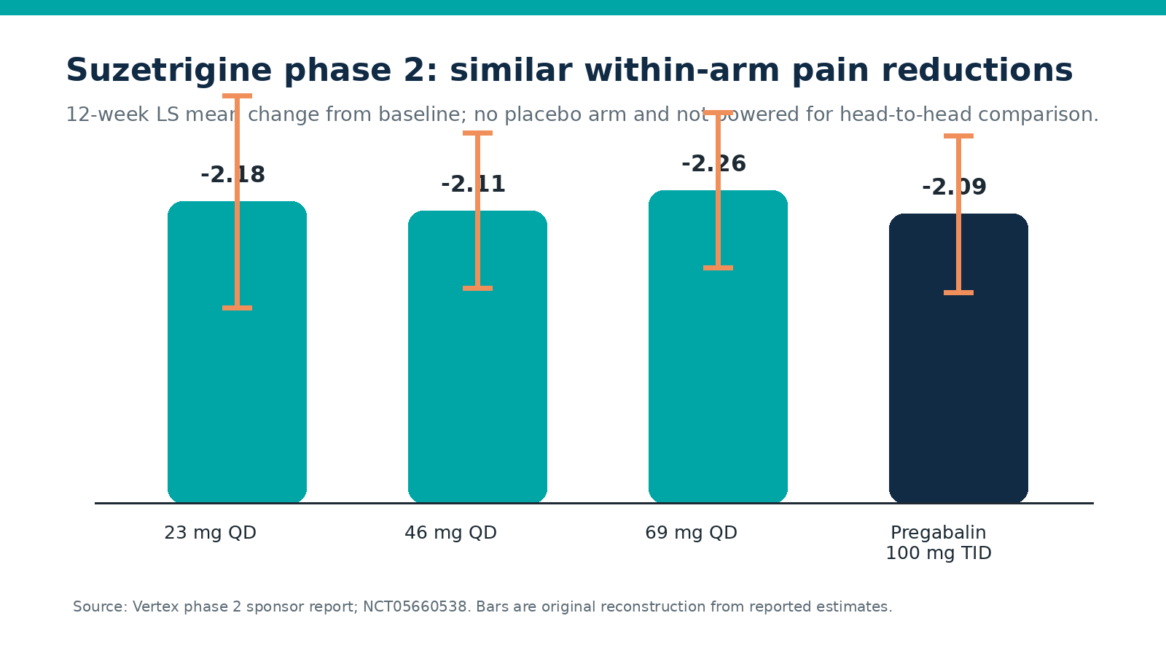
Source: Vertex phase 2 results. Original reconstruction.

Why NaV1.8 is different
Action potentials in injured sensory axons depend on a family of voltage-gated sodium channels. Older blockers such as lidocaine, carbamazepine, and mexiletine affect multiple channel isoforms and tissues. NaV1.8 is a tetrodotoxin-resistant channel expressed mainly in peripheral sensory neurons and helps sustain repetitive nociceptor firing. A selective inhibitor can therefore lower the gain of damaged pain fibers before the signal enters the spinal cord while aiming to preserve normal central cognition, respiration, and reward circuitry.
That selectivity solves an analgesic safety problem, not the underlying metabolic and microvascular injury. If a trial measures only daily pain, it cannot show restored afferent signal fidelity. Future NaV1.8 studies should include sensory detection, autonomic small-fiber measures, and foot-safety outcomes to ensure that suppressing painful firing does not further mask protective sensation.

Suzetrigine: strong signal, important design caveat
The phase 2 DPN study randomized 192 adults with bilateral lower-extremity pain for at least one year to 23, 46, or 69 mg suzetrigine once daily or pregabalin 100 mg three times daily for 12 weeks. It had no placebo arm and was not powered to compare suzetrigine with pregabalin. All arms improved from baseline, and the three suzetrigine dose-response curves overlapped. More than 30% of participants in each suzetrigine group achieved at least 50% pain reduction; corresponding pregabalin response was 22%. Creatinine-clearance decrease was reported in 5.1% versus 1.9%, dizziness in 0.7% versus 9.3%, peripheral edema in 0.7% versus 5.6%, and weight increase in 0% versus 7.4% for pooled suzetrigine versus pregabalin (Vertex detailed results).
Interpretation: the result validates NaV1.8 as a plausible DPN analgesic target and suggests fewer classic pregabalin adverse effects. Yet each suzetrigine p value tests change from baseline, not superiority to placebo. Regression to the mean, expectancy, and study participation can generate substantial baseline improvement in pain trials. Phase 3 placebo comparison is therefore the decisive efficacy test.
The first pivotal study is randomized, double-blind, placebo- and active-controlled, plans about 1,100 participants, and compares 70 mg once-daily suzetrigine with placebo; pregabalin provides an active benchmark. The primary endpoint is the week-12 change in weekly average daily pain intensity, and a key secondary analysis tests non-inferiority to pregabalin before potential superiority. Enrollment is ongoing and primary completion is estimated for 31 May 2027 (NCT06628908). A second placebo-controlled phase 3 study is also recruiting and uses the same week-12 pain endpoint (NCT07231419); a 455-participant open-label extension is active but no longer recruiting and is intended to characterize longer-term safety (NCT06696443).

Regulatory and safety reality
FDA approval of suzetrigine for acute pain establishes manufacturing, short-course clinical safety, and peripheral analgesic activity, but it does not authorize DPN use or prove long-term benefit. The current label contraindicates strong CYP3A inhibitors, requires avoidance of grapefruit, includes dosing adjustments with moderate CYP3A inhibitors and hepatic impairment, and warns that suzetrigine can reduce exposure to CYP3A substrates, including some hormonal contraceptives (FDA prescribing information). Chronic DPN development must address months-to-years exposure, polypharmacy, renal and hepatic comorbidity, falls, protective sensation, and rare adverse events that acute surgical trials could not reveal.

What other sodium-channel programs teach
Vixotrigine, a voltage- and use-dependent sodium-channel blocker rather than an isoform-pure NaV1.8 drug, used an enriched-enrollment randomized-withdrawal design in idiopathic or diabetes-associated painful small-fiber neuropathy. Of 265 participants receiving open-label drug, only 123 responders were randomized. At week 12, 200 mg twice daily beat placebo by 0.85 pain points (95% CI −1.71 to 0.00; p=0.050 under a prespecified two-sided alpha of 0.10), whereas 350 mg did not (difference −0.17; 95% CI −1.01 to 0.68; p=0.70). Falls, nasopharyngitis, muscle spasm, and urinary infection were among common events (CONVEY trial). The non-monotonic dose result and responder enrichment limit generalizability, but demonstrate how use-dependent channel blockade may benefit a phenotype rather than an entire DPN population.
NaV1.7 remains genetically compelling—loss-of-function causes profound insensitivity to pain—but clinical translation has repeatedly been harder than genetics suggested. For DPN, the near-term opportunity is phenotype selection: enrich for preserved fibers with hyperexcitability, burning pain, and objective small-fiber dysfunction, rather than advanced painless axon loss where there is little excitable substrate left to inhibit.

3. Neurovascular and axonal repair: higher upside, harder proof
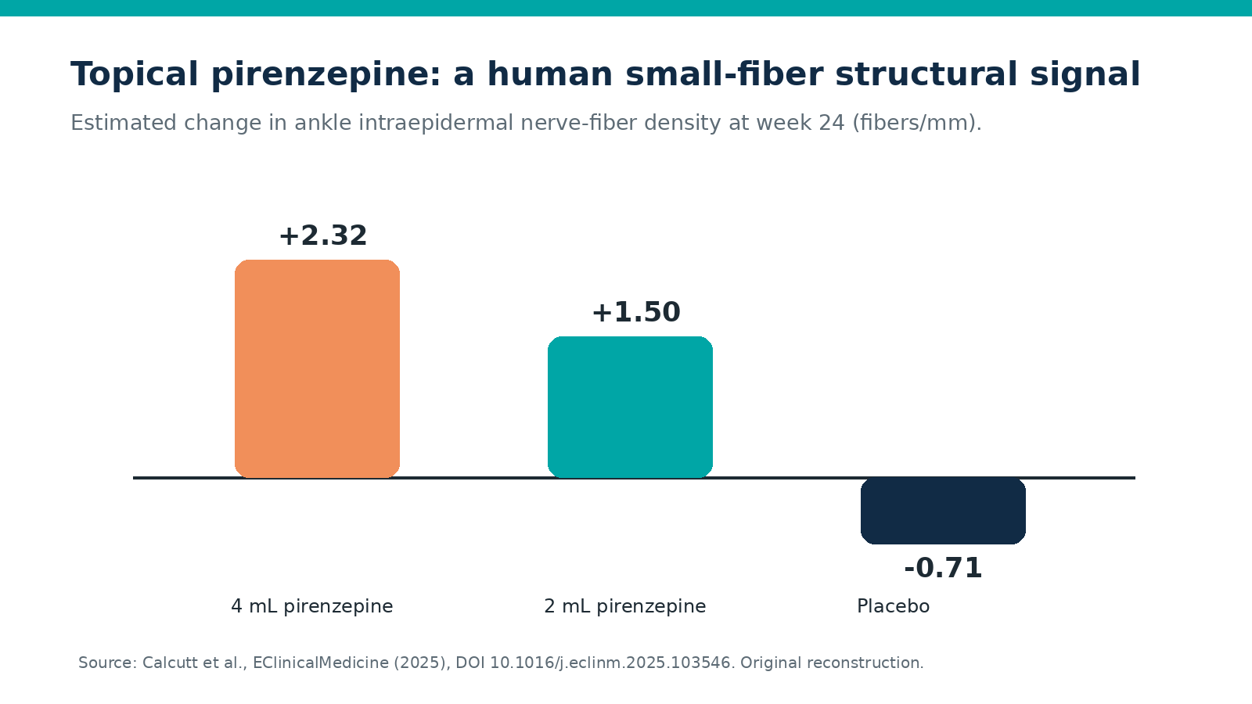
Source: Calcutt et al., 2025. Original reconstruction.

Topical pirenzepine: the leading structural signal
Pirenzepine is being repurposed locally to inhibit M1 muscarinic signaling, which preclinical work identifies as a restraint on mitochondrial function and neurite growth. Topical delivery aims to expose distal terminals while limiting systemic anticholinergic effects. In diabetic mice, topical pirenzepine prevented or reversed indices of thermal sensory dysfunction and nerve loss, providing the mechanistic bridge to human testing (preclinical study).
The Canadian phase 2a trial enrolled 58 adults with definite type 2 DPN across five university centers and randomized them to once-daily 4% pirenzepine, 2 or 4 mL, or placebo for 24 weeks. Safety and tolerability were primary; ankle IENFD and Norfolk Quality of Life–Diabetic Neuropathy were pilot efficacy endpoints. The IENFD results favored both doses, with the larger estimated change at 4 mL. Rates of adverse events considered possibly, probably, or definitely related were 50.0% at 4 mL, 36.3% at 2 mL, and 41.7% with placebo (peer-reviewed phase 2a article).
This is the most direct recent human evidence compatible with distal small-fiber regrowth. It is still limited evidence: small groups, a biomarker endpoint, multiple pilot outcomes, 24-week follow-up, and no demonstrated reduction in ulcers or restoration of large-fiber conduction. A phase 3 program should use central blinded biopsy reading, a prespecified between-group estimand, multiplicity control, function co-primary or hierarchical secondary endpoints, and post-treatment follow-up.

HGF gene therapy: biologically elegant, clinically negative
VM202 is a nonviral plasmid encoding two hepatocyte-growth-factor isoforms, injected into calf muscle. HGF has angiogenic, neurotrophic, and anti-apoptotic actions, making it an archetypal neurovascular-repair strategy. Earlier phase 1/2 data suggested pain benefit, particularly at higher exposure (phase 1/2 publication).
The subsequent phase 3 program randomized 500 participants (336 VM202; 164 placebo) and included a 101-person noninterventional extension. The main study did not separate from placebo on its primary pain endpoint or other reported efficacy measures. Exploratory benefit in participants not taking gabapentin or pregabalin was hypothesis-generating and vulnerable to subgroup and post-randomization interpretation (phase 3 publication; registry results).
The lesson is not that neurovascular repair is futile. It is that angiogenic plausibility plus pain relief is an inadequate development package. Local transgene expression, target engagement in nerve rather than muscle, baseline microvascular phenotype, and objective neural rescue were not established strongly enough to explain or predict clinical response.

Other repair approaches: interesting, not yet decisive
Approaches aimed at erythropoietin’s innate-repair receptor, vascular endothelial growth factor pathways, mitochondrial function, Schwann-cell support, cell therapy, and physical neuromodulation remain mostly preclinical, early clinical, or indirect for distal symmetric DPN. Cibinetide (ARA 290), for example, produced corneal small-fiber signals in sarcoidosis-associated neuropathy, but that disease and trial cannot establish efficacy in diabetic neuropathy (NCT02039687). Such programs should not be ranked alongside DPN-specific randomized evidence.

4. A rational next-generation trial architecture

Two programs, not one blurred claim
Program A: selective analgesia. Enroll painful DPN with objective neuropathy and sufficient residual small-fiber function. Randomize NaV1.8 inhibitor, placebo, and active comparator for 12–16 weeks, followed by at least one year of controlled or carefully benchmarked safety. The estimand should quantify treatment-policy benefit despite rescue therapy. Key outcomes are pain, sleep, physical function, patient global impression, rescue use, tolerability, and withdrawal.
Program B: disease modification. Enroll early-to-moderate DPN enriched for demonstrable axonal loss but repair capacity. Randomize a local regenerative or neurovascular intervention against vehicle/placebo for 12–18 months. A hierarchical endpoint could require: (1) structural improvement in IENFD or corneal nerve-fiber length; (2) functional improvement in sural sensory amplitude, conduction, or validated quantitative sensory testing; and (3) patient-relevant improvement in balance, gait, sensation, or quality of life. Continue observation after dosing stops to test durability.
Corneal confocal microscopy is attractive because it is rapid and non-invasive; a meta-analysis of roughly 4,000 participants found consistent reductions in corneal nerve-fiber density, branching, and length in diabetes with and without clinically defined neuropathy. However, cross-platform acquisition, analysis algorithms, and thresholds require standardization before a pivotal surrogate claim (systematic review). Skin-biopsy IENFD is more directly distal but invasive and sampling-variable. Using both in a subset would help establish concordance.

Combination strategy
A combination of NaV1.8 inhibition and a repair agent is scientifically appealing: immediate analgesia may improve adherence and function while repair develops. It is also methodologically dangerous. Analgesia can unblind treatment, obscure worsening sensory loss, and make pain an uninterpretable repair endpoint. The correct sequence is factorial or add-on testing after each component has independent efficacy, with structural and functional outcomes protected from symptom-driven bias.

Safety and monitoring
A reversal trial should actively monitor:
- Neurologic examination, vibration and monofilament detection, autonomic symptoms, and nerve conduction.
- Falls, gait, orthostasis, foot temperature, wounds, infection, ulceration, and amputation.
- Glycemic trajectory, renal and hepatic function, concomitant analgesics, and CYP3A interactions for suzetrigine.
- Anticholinergic symptoms and local skin reactions for pirenzepine.
- Retinopathy, edema, unwanted angiogenesis, malignancy signals, immune responses, and vector biodistribution for growth-factor or gene approaches.
These are not generic precautions. They address the central paradox of DPN development: reducing pain must not conceal declining protective sensation, and promoting vascular growth must not create off-target harm.

5. Documented development examples and what they show
- Suzetrigine phase 2 (N=192): promising pain reduction and a favorable short-term tolerability comparison, but no placebo arm; phase 3 must establish the treatment effect (NCT05660538).
- Suzetrigine pivotal program: two placebo-controlled phase 3 studies plus a long-term extension directly address the main phase 2 limitations, although their primary endpoint remains analgesic rather than regenerative (NCT06628908; NCT06696443).
- Vixotrigine CONVEY (265 exposed; 123 randomized responders): a small signal at 200 mg but not 350 mg shows the value and interpretive cost of responder enrichment (EClinicalMedicine).
- Pirenzepine phase 2a (N=58): a human structural small-fiber signal that now requires functional and clinical validation (EClinicalMedicine).
- VM202 phase 3 (N=500): a negative pivotal trial showing that neurotrophic/angiogenic mechanism and subgroup signals cannot substitute for a positive randomized primary endpoint (Clinical and Translational Science).
- DCCT (N=1,441): strong prevention evidence demonstrates that modifying the upstream metabolic exposure works best early, while underscoring how much harder reversal of established axon loss is (Annals of Internal Medicine).

Practical synthesis
For clinical practice in 2026, neither suzetrigine nor pirenzepine should be represented as an approved DPN-reversal treatment. Suzetrigine’s acute-pain approval does not establish chronic DPN dosing or safety. Standard DPN care—individualized glycemic and cardiovascular risk management, evaluation for alternative neuropathy causes, foot surveillance, fall prevention, and evidence-based pain treatment—continues while pivotal trials mature.
For trial selection, match mechanism to phenotype. Painful, hyperexcitable, fiber-preserved DPN is the rational NaV1.8 population. Early-to-moderate structural loss with measurable regenerative reserve is the rational repair population. End-stage insensate neuropathy with severe axon depletion is unlikely to respond quickly to either strategy and may require a different endpoint horizon.
For investment and development, the risk-adjusted ranking is:
- Suzetrigine for pain control — moderate-to-strong promise, not reversal. Phase 3 and regulatory de-risking in acute pain make it the leading near-term candidate.
- Topical pirenzepine for small-fiber repair — promising but limited. It has the best recent human biomarker signal and the largest evidentiary gap between structure and meaningful function.
- Next-generation locally targeted neurovascular repair — high theoretical upside, unproven. Advancement should require demonstrable target engagement and neural—not merely muscular or pain—effects.
- HGF gene therapy as currently evidenced — mixed-to-negative. The pivotal null result dominates exploratory subgroups.
- Broad or incompletely selective sodium-channel blockade — limited/mixed. Vixotrigine shows phenotype-level activity but no clean dose response.
The breakthrough will not be a pain score presented as nerve regeneration. It will be a therapy that produces concordant, durable improvement in structure, electrophysiology or sensory function, and real-world protection, with an adverse-event profile compatible with years of use.

Evidence and caveats
This review prioritizes trial registries, FDA records, and peer-reviewed primary trials. Some numerical suzetrigine phase 2 details are currently available principally through the sponsor’s report and registry rather than a full peer-reviewed article; they should be considered sponsor-reported. Ongoing studies have no results and their completion dates may change. Pirenzepine’s phase 2a estimates are small-sample biomarker findings. VM202 subgroup findings are exploratory after a negative primary analysis. No head-to-head evidence compares a regenerative strategy with selective NaV1.8 inhibition, and no trial shows that combining them reverses DPN.
Evidence strength is moderate for NaV1.8-mediated analgesic activity, limited but promising for pirenzepine-mediated small-fiber repair, mixed-to-negative for HGF gene therapy, and unproven for clinical neurovascular restoration that prevents ulcers or restores protective sensation.

Sources
Claim supported | Evidence type | Primary source | Direct URL
Suzetrigine DPN phase 2 design, pain changes, confidence intervals, and adverse events | Primary, sponsor-reported clinical trial results | Vertex Pharmaceuticals. Phase 2 VX-548 DPN results, 2023; NCT05660538 | https://news.vrtx.com/news-releases/news-release-details/vertex-announces-positive-results-phase-2-study-vx-548-treatment
Suzetrigine phase 2 participant flow and registered results | Primary registry record | ClinicalTrials.gov. NCT05660538 | https://clinicaltrials.gov/study/NCT05660538?tab=results
First pivotal suzetrigine DPN trial design and status | Primary registry record | ClinicalTrials.gov. NCT06628908 | https://clinicaltrials.gov/study/NCT06628908
Second pivotal suzetrigine DPN trial design and status | Primary registry record | ClinicalTrials.gov. NCT07231419 | https://clinicaltrials.gov/study/NCT07231419
Suzetrigine long-term DPN safety extension | Primary registry record | ClinicalTrials.gov. NCT06696443 | https://clinicaltrials.gov/study/NCT06696443
FDA acute-pain indication and approval date | Official regulatory record | FDA. Journavx approval announcement, 2025 | https://www.fda.gov/news-events/press-announcements/fda-approves-novel-non-opioid-treatment-moderate-severe-acute-pain
Suzetrigine contraindications, interactions, and labeled safety | Official regulatory label | FDA. Journavx prescribing information, revised 2026 | https://www.accessdata.fda.gov/drugsatfda_docs/label/2026/219209s009lbl.pdf
Pirenzepine phase 2a IENFD and safety results | Primary peer-reviewed trial | Calcutt et al. EClinicalMedicine, 2025. DOI 10.1016/j.eclinm.2025.103546 | https://doi.org/10.1016/j.eclinm.2025.103546
Pirenzepine trial registration and prespecified design | Primary registry record | ClinicalTrials.gov. NCT04005287 | https://clinicaltrials.gov/study/NCT04005287
Topical pirenzepine preclinical reversal rationale | Primary preclinical study | Calcutt et al. Diabetes, 2020. PMID 32327528 | https://pubmed.ncbi.nlm.nih.gov/32327528/
VM202 phase 3 randomized null result | Primary peer-reviewed trial | Kessler et al. Clinical and Translational Science, 2021. DOI 10.1111/cts.12977 | https://doi.org/10.1111/cts.12977
VM202 registered phase 3 results | Primary registry record | ClinicalTrials.gov. NCT02427464 | https://clinicaltrials.gov/study/NCT02427464?tab=results
Earlier VM202 dose-finding signal | Primary peer-reviewed trial | Kessler et al. Annals of Clinical and Translational Neurology, 2015. PMID 26000320 | https://pubmed.ncbi.nlm.nih.gov/26000320/
Vixotrigine enriched-withdrawal efficacy and safety | Primary peer-reviewed trial | Faber et al. EClinicalMedicine, 2023. DOI 10.1016/j.eclinm.2023.101971 | https://doi.org/10.1016/j.eclinm.2023.101971
Intensive glycemic therapy and neuropathy prevention | Primary randomized trial | DCCT Research Group. Ann Intern Med, 1995. DOI 10.7326/0003-4819-122-8-199504150-00001 | https://doi.org/10.7326/0003-4819-122-8-199504150-00001
Long-term DCCT/EDIC neuropathy outcomes | Primary cohort follow-up of randomized trial | Albers et al. Diabetes Care, 2010. PMID 20150297 | https://pubmed.ncbi.nlm.nih.gov/20150297/
DPN treatment recommendations and opioid caution | Official professional guideline | American Diabetes Association. Standards of Care in Diabetes—2025 | https://pmc.ncbi.nlm.nih.gov/articles/PMC11635040/
Corneal confocal microscopy diagnostic biomarker evidence | Secondary systematic review | Gad et al. Journal of Diabetes Investigation, 2022 | https://pmc.ncbi.nlm.nih.gov/articles/PMC8756328/
Human endoneurial microvascular pathology association | Primary human pathology study | Malik et al. Diabetologia, 1993. PMID 8314451 | https://pubmed.ncbi.nlm.nih.gov/8314451/
Limits of a simple ischemia model | Secondary mechanistic synthesis | Østergaard et al. Journal of Diabetes Research, 2015 | https://pmc.ncbi.nlm.nih.gov/articles/PMC4351434/
Explore more questions at Ask Anything

