Beyond the Greenwald Density Limit on EAST
  - How ECRH-assisted startup, neutral prefill, and tungsten-wall plasma–wall self-organization reached 1.65 nG—and what “density-free” does and does not mean
ASK ANYTHING / EVIDENCE BRIEF / 26 JULY 2026
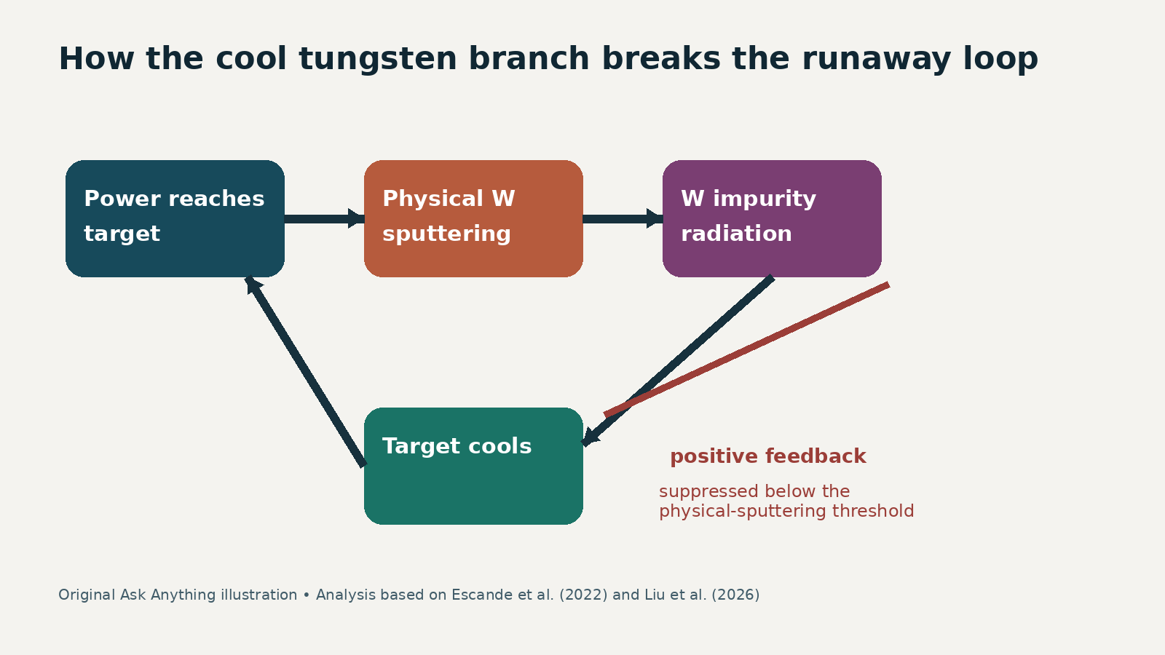
For fusion scientists, tokamak experimentalists, plasma–surface-interaction researchers, and program decision-makers.

Contents
01 Executive summary
02 Key findings
03 What limit was exceeded?
04 The experimental recipe
05 Mechanism: why cooling did not trigger thermal collapse
06 Why tungsten matters—and why it remains risky
07 Evidence strength, alternatives, and limitations
08 Documented experimental examples
09 Practical synthesis
10 Evidence and caveats
Sources

Executive summary
The EAST result was a controlled change of the discharge’s startup trajectory, not a brute-force increase in flat-top heating. In two shot series, researchers varied the deuterium prefill at roughly 600 kW of electron-cyclotron resonance heating (ECRH), or varied ECRH from 0 to 600 kW at the lowest prefill. The resulting ohmic plasmas reached line-averaged densities of 1.3–1.65 times the Greenwald value, compared with EAST’s usual 0.8–1.0 range. The central density diagnostic was a vertical interferometer; the representative case used 2.5 T, 250 kA, 600 kW ECRH from 0 to 4.5 s, and 6.6×10¹⁹ prefilled D₂ molecules. https://doi.org/10.1126/sciadv.adz3040
The causal interpretation is a plasma–wall feedback story. More initial neutrals and ECRH made breakdown and current ramp-up more robust at higher density, while successive discharges conditioned the wall. Near the later density ramp, higher-performing shots showed lower target-region electron temperature, lower effective charge Z_eff, and lower total radiation. With tungsten plasma-facing components, impurity production is dominated by physical sputtering, whose yield collapses below an impact-energy threshold. Cooling the target therefore suppresses the tungsten source; lower impurity radiation leaves less scope for the positive loop “wall power → sputtering → radiation → cooling → collapse.” This behavior is the low-target-temperature basin predicted by plasma–wall self-organization (PWSO). https://doi.org/10.1088/1741-4326/ac3a65
The experiment supports the PWSO mechanism, but the language requires discipline. “Density-free” names a basin of the model in which the predicted radiative density threshold moves to very high values as target temperature falls; it does not mean density can increase without bound. The shots were low-current, lower-single-null, ohmic or ECRH-assisted startup discharges, not reactor-relevant burning H-mode plasmas. Density was increased until collapse, and the representative discharge terminated near 1.5 nG. The authors explicitly propose testing higher ECRH/prefill and detached, high-performance operation next. https://pmc.ncbi.nlm.nih.gov/articles/PMC12757026/

Key findings
1. The startup state mattered more than the late heating increment. Raising prefill at fixed ~600 kW produced the clearest density-limit increase; at the lowest prefill, adding 600 kW raised two paired limits only from 4.9 to 5.2×10¹⁹ m⁻³ and from 5.5 to 5.6×10¹⁹ m⁻³. The paper attributes the weak ECRH-only response to insufficient particles at startup. https://doi.org/10.1126/sciadv.adz3040
2. The highest line-averaged result was 1.65 nG, not a separatrix density of 1.65 nG. The central-chord line average exceeded the Greenwald normalization, while the reconstructed separatrix density remained below 0.75 nG in all analyzed shots. That distinction is important when comparing to edge-density limits or reactor pedestal constraints. https://pmc.ncbi.nlm.nih.gov/articles/PMC12757026/
3. Tungsten was useful because its impurity source can switch off sharply. Carbon’s chemical sputtering persists at low target temperature; tungsten’s physical sputtering falls strongly below threshold. In PWSO, this makes a cool-target fixed point possible in which the radiation feedback gain α stays below unity. https://doi.org/10.1088/1741-4326/ac3a65
4. The evidence is internally coherent but not uniquely causal. Density limit, target temperature, Z_eff, and radiation co-varied in the predicted direction, and both zero- and one-dimensional PWSO calculations placed EAST points in the low-temperature basin. Yet identical nominal input settings produced different outcomes, which the authors associate with evolving wall conditions. The study was neither randomized nor designed to isolate ECRH, prefill, lithiation, and discharge history independently. https://doi.org/10.1126/sciadv.adz3040
5. Crossing nG is not unprecedented, but this route is distinct. DIII-D reported a high-density, high-confinement regime above nG, and the Madison Symmetric Torus reached much larger Greenwald fractions in a low-aspect-ratio, low-field configuration. Those results do not validate the same PWSO trajectory, nor do Greenwald fractions alone make unlike machines equivalent. https://doi.org/10.1038/s41586-024-07313-3 https://doi.org/10.1103/PhysRevLett.133.055101

What limit was exceeded?
The Greenwald density is an empirical normalization, conventionally written n_G[10²⁰ m⁻³] = I_p[MA]/(πa²[m²]). It captures a broad disruption boundary but is not a first-principles hard ceiling. Its interpretation depends on whether one uses volume- or line-averaged density, which chord is used, plasma shape, edge density, heating regime, and the failure mode. Greenwald’s review documents both the utility and the scatter of the scaling. https://doi.org/10.1088/0741-3335/44/8/201
For EAST’s typical 250 kA and minor radius near 0.45 m, the nominal expression gives about 3.9×10¹⁹ m⁻³; geometry and the experimental analysis determine the shot-specific normalization. The measured maxima in the table span 4.8–5.6×10¹⁹ m⁻³. The publication reports the resulting range as 1.3–1.65 nG and uses maximum density immediately before disruption as the “density limit.” https://doi.org/10.1126/sciadv.adz3040
This is therefore best described as exceeding EAST’s conventional Greenwald-normalized operational boundary while following a PWSO-consistent low-impurity trajectory. It is not evidence that all density limits disappear: turbulent edge transport, magnetohydrodynamic stability, fueling, detachment control, confinement, and exhaust remain independent constraints. A first-principles edge-turbulence model, for example, predicts a power- and geometry-dependent density boundary rather than a universal wall-radiation threshold. https://doi.org/10.1103/PhysRevLett.128.185003

The experimental recipe
Platform and diagnostics. EAST has full metal walls and tungsten divertors. The analyzed experiments used lower-single-null plasmas, I_p≈250 kA, B_T≈2.5 T, elongation ≈1.5, triangularity ≈0.5, gas-puff density feedback, and lithiation. Line-averaged density came from interferometry; target electron temperature from embedded divertor triple probes; total radiation from a bolometer; impurity emission from an extreme-ultraviolet spectrometer; and Z_eff from visible bremsstrahlung. https://pmc.ncbi.nlm.nih.gov/articles/PMC12757026/ https://doi.org/10.1007/s10894-015-0039-9
Two parameter scans. One series held ECRH near 600 kW and increased the prefilled D₂ amount from 0.66 to 1.73×10²⁰ molecules. The tabulated density limit rose from 5.2 to 5.4×10¹⁹ m⁻³ and saturated across the final points. A second comparison at the 0.66×10²⁰ prefill changed ECRH between 0 and 600 kW. Across shot history, densities ranged from 4.8 to 5.6×10¹⁹ m⁻³. https://doi.org/10.1126/sciadv.adz3040
Representative trajectory. Shot 143069 began with ECRH concurrent with ohmic startup. ECRH lasted 4.5 s; hydrogen was the working gas, with no seeded impurity. Gas injection continued through the current plateau under density feedback. The plasma reached approximately 1.5 nG, then density fell rapidly and the discharge ended without a reported precursor in the monitored magnetohydrodynamic activity. https://pmc.ncbi.nlm.nih.gov/articles/PMC12757026/
What changed at the wall. At higher prefill, the later 5–6 s averaging window showed a cooler lower-outer target, less total radiation, and lower Z_eff. In a sequence of nominally comparable shots, target temperature and Z_eff decreased while the achieved density increased, consistent with progressive wall conditioning. This history dependence is not a nuisance detail; it is central to the “self-organization” claim. https://doi.org/10.1126/sciadv.adz3040
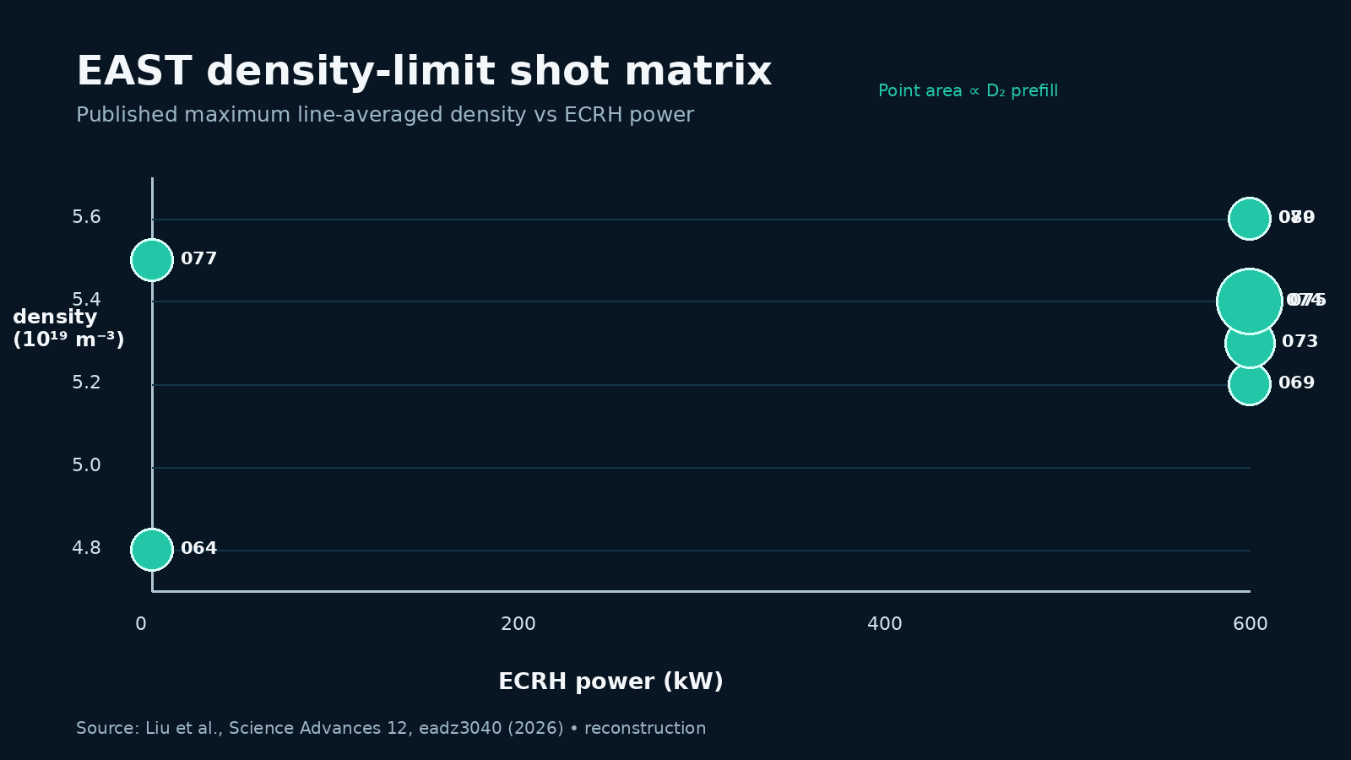
Figure 1. Reconstructed shot matrix. Source: Liu et al., Science Advances (2026).

Mechanism: why cooling did not trigger thermal collapse
Ordinarily, rising density can increase impurity radiation. Radiation cools the edge; a cooler edge may broaden the radiating region and change transport, while power reaching plasma-facing components controls how many wall atoms enter the plasma. If impurity production and radiation amplify one another faster than heating and transport can compensate, a radiative collapse follows. PWSO represents the delayed loop as R₊ = α(P−R), where P is input power, R is current radiation, R₊ is the next-cycle impurity radiation, and α is the loop gain. The fixed point loses stability for α>1. https://doi.org/10.1088/1741-4326/ac3a65
The critical feature is that α contains the sputtering-yield average I(T_t), divided by target temperature T_t. For tungsten, physical sputtering has a threshold in projectile energy. As the divertor target cools sufficiently, I(T_t) collapses faster than the explicit 1/T_t factor grows. The impurity source therefore turns down: fewer tungsten atoms enter the confined plasma, Z_eff and radiation decline, and α remains below one. PWSO predicts two attraction basins—one on the warmer, sputtering-active branch with a finite radiative density limit, and another on the cooler branch where the modeled threshold rises steeply. https://doi.org/10.1126/sciadv.adz3040
ECRH’s role was indirect and phase-specific. Resonant microwave power assists pre-ionization and electron heating during breakdown, allowing current formation with more neutral gas and less damaging plasma–wall interaction. The resulting startup enters flat-top with a cleaner wall/plasma state. Separate EAST spectroscopy has also observed reduced core W⁴⁴⁺ concentration with on-axis ECRH, but that transport result should not be conflated with the startup PWSO experiment; it is supporting evidence that ECRH can alter tungsten behavior, not the causal test reported here. https://arxiv.org/abs/2210.17129
The phrase “without thermal collapse” applies to the path to the reported maximum: the impurity-dominated positive feedback was suppressed long enough to pass the conventional boundary. It does not mean the pulses were indefinitely stationary. The experiment defined the limit at collapse and drove gas until termination. The scientifically defensible claim is delayed radiative/thermal failure at a much higher line average, not permanent elimination of collapse. https://pmc.ncbi.nlm.nih.gov/articles/PMC12757026/
Figure 2. Original Ask Anything mechanism diagram. Analysis: PWSO theory and EAST experiment.

Why tungsten matters—and why it remains risky
PWSO contrasts tungsten with carbon. Carbon chemical sputtering can persist even when incident energies are low, so cooling the target does not switch the impurity source off as cleanly. Tungsten’s high atomic number makes even trace core concentrations radiatively consequential, but its physical-sputtering threshold creates the nonlinearity needed for the low-temperature basin. EAST’s two full tungsten divertors and full-metal wall therefore supplied a more stringent test than J-TEXT’s carbon-dominated wall, whose ECRH-assisted shots remained in the finite-limit basin. https://doi.org/10.1088/1741-4326/ace91c
The same property is a liability outside the favorable basin. If target ions are energetic enough to sputter tungsten, high-Z radiation can rapidly degrade performance; erosion, redeposition, dust, transient heat loads, and core accumulation remain serious engineering issues. The EAST result is not “tungsten eliminates impurities.” It is “a sufficiently cool, conditioned tungsten target can suppress the dominant physical source.” That conditional formulation is the transferable design insight. https://doi.org/10.1007/s10894-015-0039-9
Lithiation was used in these experiments and may have reduced recycling or impurity influx, but the reported scan did not isolate its contribution. Similarly, shot-to-shot evolution shows that “prefill + ECRH power” is not a complete control law. A deployable PWSO scenario will need observable state variables—target T_e, radiation fraction and localization, Z_eff or W spectroscopy, recycling, and wall inventory—rather than feed-forward startup settings alone. https://pmc.ncbi.nlm.nih.gov/articles/PMC12757026/

Evidence strength, alternatives, and limitations
Strong for the observation. Eight listed EAST shots, multiple diagnostics, and a clear maximum establish that the specified low-current scenario reached 1.3–1.65 nG. The table reports exact shot IDs, ECRH power, prefill, and maximum density; the paper and supplement contain the data needed to evaluate the result. https://doi.org/10.1126/sciadv.adz3040
Moderate for the PWSO interpretation. The measured correlations—cooler target, lower Z_eff, lower radiation, higher density—and agreement with both 0D and 1D calculations match the model’s direction. The prior J-TEXT test provides an informative material contrast. However, the EAST comparison is a small, history-dependent experimental series, and key coefficients in the reduced model are not independently identified shot by shot. https://doi.org/10.1088/1741-4326/ace91c
Limited for reactor extrapolation. The experiment was ohmic/ECRH-assisted, approximately 250 kA, and not a deuterium–tritium burning plasma. It did not report fusion gain, triple product improvement, long-pulse duration at 1.65 nG, or high-confinement compatibility. The authors frame higher ECRH, higher prefill, and detached operation as future possibilities, not demonstrated results. https://doi.org/10.1126/sciadv.adz3040
Competing and complementary explanations remain. Contemporary density-limit work attributes boundaries to edge turbulent transport, shear-layer collapse, radiation condensation, detachment and magnetohydrodynamic processes, with regime-specific importance. PWSO need not exclude those mechanisms; it claims that plasma–wall impurity feedback can create or remove one important power-balance boundary. Comparing only n/nG cannot adjudicate among mechanisms. https://doi.org/10.1103/PhysRevLett.128.185003
No claim of universal precedence. Other devices have exceeded nG using different operating regimes. DIII-D combined high density with high confinement, while MST’s very high normalized densities occurred in a substantially different tokamak parameter space. EAST’s novelty is the experimentally mapped, tungsten-enabled PWSO basin reached through ECRH-assisted ohmic startup, as characterized by the authors. https://doi.org/10.1038/s41586-024-07313-3 https://doi.org/10.1103/PhysRevLett.133.055101

Documented experimental examples
EAST shot 143069: 600 kW ECRH, 0.66×10²⁰ D₂ prefill, and a 5.2×10¹⁹ m⁻³ maximum; used as the time-history reference. https://pmc.ncbi.nlm.nih.gov/articles/PMC12757026/
EAST prefill scan, shots 143073–143075: at 600 kW, raising prefill from 1.0 to 1.73×10²⁰ molecules increased the tabulated limit from 5.3 to 5.4×10¹⁹ m⁻³, after which it saturated at the available power. https://doi.org/10.1126/sciadv.adz3040
EAST shot-history pair: shots 143069 and 143079 had nominally identical ECRH/prefill but limits of 5.2 and 5.6×10¹⁹ m⁻³, evidence that wall state—not just commanded inputs—affected the outcome. https://pmc.ncbi.nlm.nih.gov/articles/PMC12757026/
J-TEXT validation: higher prefill or ECRH reduced carbon radiation and raised the density limit, but the carbon-dominated device remained on PWSO’s finite-limit branch. https://doi.org/10.1088/1741-4326/ace91c
DIII-D comparison: a 2024 Nature paper demonstrated a high-density, high-confinement regime, showing that profile and confinement control can also exceed conventional Greenwald expectations. It is a comparator, not a replication of EAST’s tungsten PWSO startup. https://doi.org/10.1038/s41586-024-07313-3
MST comparison: a 2024 Physical Review Letters study reported tokamak plasmas up to ten times nG in a low-field, low-aspect-ratio device, underscoring that n/nG is an empirical normalization rather than a universal similarity parameter. https://doi.org/10.1103/PhysRevLett.133.055101

Practical synthesis
For experimental transfer, the most credible control sequence is: establish a high-neutral, ECRH-assisted breakdown; minimize early wall bombardment; track target T_e and radiation as state variables; maintain the tungsten target below the physical-sputtering-active branch; then raise density under feedback while guarding separatrix density, radiation localization, W concentration, and MHD stability. This sequence is an Ask Anything synthesis of the reported evidence, not a validated universal recipe. https://doi.org/10.1126/sciadv.adz3040
A decisive next experiment would use a factorial or adaptive design across prefill, ECRH waveform, wall conditioning, and shot order, with reproducible wall-state diagnostics. It should hold plasma current and shape fixed, measure absolute radiated power and tungsten influx, report dwell time above nG, and test both L-mode and H-mode. A causal demonstration would show that crossing the predicted sputtering threshold changes the loop gain and density-limit branch reversibly. This paragraph is prospective analysis.
For reactor relevance, success criteria should extend beyond n/nG: sustained high pedestal and volume density; confinement and triple product; compatibility with detachment and alpha heating; impurity residence time; divertor erosion; disruption avoidance; and controllability under long-pulse wall inventory evolution. The EAST result supplies a plausible startup and boundary-control lever, not yet an integrated burning-plasma solution. https://conferences.iaea.org/event/392/contributions/36230/

Evidence and caveats
Evidence grading: observation—strong within the tested EAST scenario; mechanism—moderate; generalization to high-performance burning plasmas—limited; claim of unlimited density—unsupported. The headline number is a line-average Greenwald fraction reached at the onset of collapse. The separatrix density stayed below 0.75 nG. ECRH power was at most 600 kW, prefill effects saturated, and identical commanded inputs did not reproduce identical outcomes. https://doi.org/10.1126/sciadv.adz3040
Safety/context boundary: this is a technical synthesis of published fusion experiments, not an operating authorization. Tokamak density ramps and disruption experiments can impose substantial electromagnetic and thermal loads; implementation belongs within facility-specific machine-protection rules and reviewed experimental proposals.

Sources
Claim supported | Evidence type | Primary source | Direct URL
EAST density, shot design, diagnostics, PWSO comparison | Primary experimental study | Liu, J. et al. “Accessing the density-free regime with ECRH-assisted ohmic start-up on EAST.” Science Advances 12, eadz3040 (2026). DOI 10.1126/sciadv.adz3040 | https://doi.org/10.1126/sciadv.adz3040
Full text, tables, methods, data availability | Primary repository record | PubMed Central full-text record for Liu et al. (2026), PMCID PMC12757026 | https://pmc.ncbi.nlm.nih.gov/articles/PMC12757026/
PWSO two-basin model and tungsten physical-sputtering mechanism | Primary theory | Escande, D. F., Sattin, F. & Zanca, P. “Plasma-wall self-organization in magnetic fusion.” Nuclear Fusion 62, 026001 (2022). | https://doi.org/10.1088/1741-4326/ac3a65
Prior ECRH/prefill PWSO validation with carbon wall | Primary experimental study | Liu, J. et al. “Validation of the plasma-wall self-organization model…” Nuclear Fusion 63, 096009 (2023). | https://doi.org/10.1088/1741-4326/ace91c
Greenwald normalization and historical density-limit evidence | Primary review / synthesis | Greenwald, M. “Density limits in toroidal plasmas.” Plasma Physics and Controlled Fusion 44, R27–R53 (2002). | https://doi.org/10.1088/0741-3335/44/8/201
Alternative edge-turbulence density-limit scaling | Primary theory + multi-machine validation | Giacomin, M. et al. “First-principles density limit scaling…” Physical Review Letters 128, 185003 (2022). | https://doi.org/10.1103/PhysRevLett.128.185003
High-density, high-confinement DIII-D comparator | Primary experimental study | Ding, S. et al. “A high-density and high-confinement tokamak plasma regime for fusion energy.” Nature 629, 555–560 (2024). | https://doi.org/10.1038/s41586-024-07313-3
Very high n/nG MST comparator | Primary experimental study | Hurst, N. C. et al. “Tokamak plasmas with density up to 10 times the Greenwald limit.” Physical Review Letters 133, 055101 (2024). | https://doi.org/10.1103/PhysRevLett.133.055101
Independent EAST tungsten profile response to ECRH | Primary experimental preprint | Lin, Z. et al. “Observation of tungsten impurity suppression with ECRH…” arXiv:2210.17129 (2022). | https://arxiv.org/abs/2210.17129
EAST tungsten divertor design | Primary engineering study | Cao, L., Zhou, Z. & Yao, D. “EAST full tungsten divertor design.” Journal of Fusion Energy 34, 1451–1456 (2015). | https://doi.org/10.1007/s10894-015-0039-9
EAST PWSO conference record and planned extensions | Official conference record | IAEA Fusion Energy Conference 2025 contribution 36230. | https://conferences.iaea.org/event/392/contributions/36230/
Explore more questions at Ask Anything

